INTRODUCTION TO INSECT PEST MANAGEMENT
for Permaculture Research Institute Urban Farmer Certification
Saturday, April 6, 2013
Presented by Neil Cunningham, Green Noise LLC
www.theothercolorgreen.wordpress.com | leavesofnoise@gmail.com

I. INTRODUCTION TO INTEGRATED PEST MANAGEMENT (IPM)
- IPM emphasizes...an adaptable decision-making process rather than a one-size-fits-all treatment regime.
- IPM rewards...knowledge and awareness of insect biology (intimacy/intuition) over uninformed treatment plans.
- IPM encourages...the use of multiple tools instead of a single tool.
- The success of IPM favors...prevention and prediction over reaction.

A. The Four Ts of Integrated Pest Management
1. Target – What species and/or life stage am I targeting?
Resource The Ohio State Insect and Pest Series- http://ohioline.osu.edu/hyg-fact/2000/
Resource VegEdge Plant Pest Fact Sheets - http://www.vegedge.umn.edu/vegpest/pests.htm
2. Timing – When do I act? When is my target the most vulnerable?
Resource Green Noise LLC Insect Pest Walk-Through Sheet http://theothercolorgreen.files.wordpress.com/2013/04/ipm_pest_walkthrough_sheet_1.pdf
3. Tool – Which tool is the best to use? Which tool is most closely aligned with my values?
Resource Great Lakes IPM - http://www.greatlakesipm.com/
Resource Gempler’s - http://www.gemplers.com/pest-mgmt
4. Technique – Are there ways I can use my tool to achieve more effective results?
Resource ATTRA Biointensive IPM - https://attra.ncat.org/attra-pub/summaries/summary.php?pub=146

B. Types of Integrated Insect Management Tools
1. Cultural
- Sanitation | Plant spacing | Plant diversity | Trap plants | Plants that attract beneficials
Crop rotation | Choosing pest-resistant plant varieties

2. Mechanical, Physical, Material
- Adjusting Airflow, Heat/cooling, Humidity, and Light
- Removing pests by hand, Pruning, Moving plants away from infested areas
- Row covers, Netting, Fences, Bagging, Reflective mulch
- Syringing (spraying water) and kaolin clay defensive mineral barrier

3. Biological
- Conservation (Saving)
- Augmentation (Adding)
- Importation of “natural enemies” (“Classic” biocontrol)

4. Monitoring and Trapping
- Sticky traps | Trapping with bait lures | Mass trapping with bait lures | Using insect degree data to predict local emergence times, egg lay, mating, and peak flying times | Precise identification of insect pests

5. Chemical
- Insecticidal soap and Horticultural Oil
- Bio-insecticides (e.g., Bt sprays, Neem oil, Spinosad, MycoStop, etc.)
- Other biorational pesticides (insect growth regulators, )
- Synthetic neurotoxic pesticide

Text by Green Noise. Version 2.2. 6-1-11. Updated April 2013

C. INSECTS

1. Insect Functions (Eight primary functions)
1) Pollinators 2) Plant-feeders 3) Predators 4) Parasitoids
5) Pathogens 6) Scavengers 7) Decomposer 8) Food

2. Sources on Insect Pests
Resource -The Ohio State, Yard and Garden: Insect and Pests Factsheet Series http://ohioline.osu.edu/lines/pests.html
Resource Garden Insect Pests http://www1.extension.umn.edu/garden/insects/

3. Timing, Target, Tools, Technique (The 4 Ts – from an insect perspective)
1. Timing (know the weeks on the calendar that your insect is vulnerable)
Example: Apple maggot flies emerge in late June through early July.

2. Target (know the life stage of the insect you’re targeting)
Example: Use yellow sticky cards to trap cabbage butterfly adults.
Use monitoring for eggs, caterpillars, and leaf damage.

3. Tools (use the right tool for the appropriate life stage of the insect you’re managing)
Example: Use soil-dwelling predator mites for soil-dwelling stages of thrips.

4. Technique (some techniques are better than others for managing insects)
Example: Spray liquid pesticide solutions like insecticidal soap on both sides of leaves and then (optional) wash off insecticidal soap after 1-2 hours to prevent damage to leaf tissue.

Resource Organic Materials Review Institute (OMRI) – www.omri.org

4. Phenology
1. When does my pest emerge? (April, May, June, July?)
- What can I do to interfere or reduce pest during the initial adult emergence?
2. When does my pest lay eggs? (April, May, June, July?)
- What can I do to interfere with or reduce egg lay?
3. When does my pest hatch from egg?
- What can I do to interfere with or reduce hatching larvae?
4. How does the larval form of my pest behave? How does it feed?
- What can I do to interfere with or reduce larval feeding?
5. How does the larval form of my pest pupate or undergo metamorphosis?
- What can I do to interfere with or reduce pupae, cocoons, or chrysalises?
6. Does my pest have a second generation?
- If so, how can I interfere with or reduce 2nd generation numbers?
7. In the fall, how and where does my pest overwinter?
- What can I do to interfere with or reduce overwintering numbers?

5. Calculating insect degree days
Insect degree days is a more precise tool for predicting insect emergence than calendar days

DD = (High temp [80] + Low temp [50]) / 2 – 50
= 65 – 50
= 15 Degree Days (DD)

Text by Green Noise. Version 2.2. 6-1-11. Updated April 2013

D. About Biological Controls

1. Biological Control
- Biological control and “Natural” control.
Biological = intentional, purposeful, designed, planned, conscious, etc.
Natural = reduction of pests without human interference

- Approaches to Biological Control
- “Classical” (Importing an exotic bio-agent to control an exotic pest)
- Augmentation (Increase bio-agents to cause a certain effect, usually reduction in pests
and/or sustained control over a critical time during a season.)
- Conservation (Save organisms, create and/or maintain habitat that attracts and sustains bio-agents).

- Types of Bio-agents (aka, natural enemies)
- Predators (e.g., lacewings, hoverfly maggots, ladybeetle larvae, etc.)
- Parasitoids (e.g., parasitic wasps)
- Plant-feeders (e.g., Aphthona spp., Galerucella spp.)
- Pathogens (e.g., Beauvaria bassiana, Bacillus thuringiensis)

- Insect shipments and release techniques
1. Finding a reputable biological control supplier
2. The cost of biological control (shipping)
3. Checking the quality of your shipment
4. Ideal release times
5. Refrigeration of living organisms top delay emergence
6. Multi-species releases
7. Association of Natural Biological Control Producers (ANBP)

Text by Green Noise. Version 2.2. 6-1-11. Updated April 2013

E. Chemical IPM Tools
Key idea: A pesticide is any A pesticide is ANY substance or mixture of substances intended for: preventing,
destroying, repelling, or mitigating any pest.

Note: The EPA definition of pesticide is—excuse the pun—broad spectrum. ANY chemical formulation that kills insects can be placed under the EPA’s definition, including fairly benign “passive” pesticides such as kaolin clay and diatomaceous earth. The definition, I believe, is reasonable because it allows for all the different categories of pesticides. The EPA definition of pesticides includes herbicides, miticides, and fungicides.
…
Conventional Pesticides (synthetic, poisons)
Organophosphates and Carbamates
MOA: Synaptic poisons. Prevents nerve impulse transmissions. Insects “think” themselves to death.
Ex. organophosphate pesticide common names: chlorpyrifos, diazinon
Ex. organophosphate pesticide brand names: DuraGuard, Knox Out GH
Ex. carbamate pesticide common names: bendiocarb
Ex. carbamate pesticide brand names: Turca

B. Chloronicotinyls (aka, Neonicitinoids) – “Imidacloprid”, “Merit”, “Marathon”, “Imicid”
MOA: Acetylcholine agonist (mimic). Inhibits nerve impulse reception, prevents normal behavior when
messages cannot be “received”

C. Insect Growth Regulators (IGR) – diflubenzuron, fenoxycarb, pyriproxifen
MOA: Chitin synthesis inhibitors or juvenile hormone mimics
Ex. pesticide brand names: Adept, Precision, Enstar II, Distance

D. Pyrethroids
Mode of action: Affects the nervous system. Axonic toxins.
Ex. pesticide common names: Pyrethrin
Ex. pesticide brand names: 1100 Pyrethrum TR, Exclude

E. Biorational Pesticides, including Botanicals*
Mode of action: Varies

E-1. Insecticidal oils and soaps
MOA: Suffocants, dessicants, immobilizes pests
Ex. Insecticidal soap – Safer Soap, Des X Insecticidal Soap Concentrate
Ex. Horticultural oil – Sesame oil, Suffix Oil‐X
Ex. Hot pepper oil, garlic, or other herbal sprays

E-2. Microbials (Pathogens)
Bacillus thuringiensis (Bt) – Dipel, Xentari
MOA: Bt enzyme degrades the stomach in the host, causing inability to feed and infection.

Beauvaria bassiana – “Mycotrol”
MOA: When Beauveria bassiana spores come into contact with vulnerable insects, they germinate.
When they germinate, the hyphae grow and dissolve the cuticle of the insect, and eventually grow inside
the insect; once inside the insect, the fungal hyphae secrete a toxin that suppresses the immune system.
When the insect is dead, B. bassiana continues to grow and outcompete intestinal bacteria.

Streptomyces fungus – Mycostop, Actinovate AG
MOA: See explanation of MycoStop in IPM folder

Trichoderma – RootShield
MOA: 1) Competitive exclusion and 2) Mycoparasitism
Text by Green Noise. Version 2.2. 6-1-11. Updated April 2013

Saccharopolysora spinosa – Spinosad, Conserve, Entrust, Tracer, Success, etc

G. Minerals (Repellents, Passive pesticides, or Dessicants)
Kaolin clay – “Surround”
MOA: When kaolin clay dries, it leaves a mineral layer that pests do not like.

Diatomaceous earth
MOA: When certain insects or slugs come into contact with diatomaceous earth, it cuts their cuticle and
causes infection or they die from dessication (aka., “water balance disruptor).

H. Botanicals* (Stomach poisons, Suffocators, Repellants, or Nervous system poisons)
Rotenone
MOA: Contact and stomach poison found in several subtropical leguminousshrubs – derris, cube, timbo

Pyrethrum/Pyrethrins – Pyganic, Safer Insect Killer with soap (III)
MOA: Nervous system stimulant. Affects the sodium channels in the nervous systems of insects.

Neem – Agroneem, AZA‐Direct, Azatrol, Ecosense, Ecoside, Neemix, Ozoneem, NeemAzad 1%
MOA: Growth inhibitor, feeding deterrent, mating disruptor.

Sabadilla – Applied as a dust with sulfur or lime. Also toxic to bees.
MOA: Contact and stomach poison made from seeds of a Lily family plant.

Ryiana – Longer residual activity. Toxic to mammals.
MOA: Stomach poison made from stems and roots of a South American shrub, Ryania speciosa.

Other – Hot pepper, herb, seed, or garlic sprays.
MOA: Irritant, surfactant, and can be used as repellant sprays.

Text by Green Noise. Version 2.2. 6-1-11. Updated April 2013

REFERENCES and RESOURCES

1. Iowa State University Entomology. (2011). Online bug guide. Found at http://bugguide.net/node/view/253649
2. This organization of insect mouthparts was described by Dr. John Luhman, an insect taxonomist and systemicist at the University of Minnesota.
3. This system of insect functions was developed over a period of time while working as an environmental educator for the Minnesota Department of Agriculture’s Biological Control Program. It was a more precise (and inclusive) way of describing insects than simply to lump them into broad, purely human-centric terms like “good” or “bad”.
4. Minnesota Department of Agriculture Biological Control Program. (2002). Major insect orders [poster]. No longer available online.
5. National Sustainable Agriculture Information Service (ATTRA). (2001). Biointensive integrated pest management: Fundamentals of sustainable agriculture. Retrieved from http://attra.ncat.org/attra-pub/ipm.html
5a. Southern Region Integrated Pest Management Center. (2011). An IPM primer. Retrieved from http://www.sripmc.org/whatisprimer.cfm
5b. Radcliffe, T. [editor]. (2011). Radcliffe’s IPM World Textbook. Retrieved from http://ipmworld.umn.edu/
6. U.S. Environmental Protection Agency. (February 11, 2011). About pesticides. Retrieved from http://www.epa.gov/opp00001/about/
7. Ferro, D.N. (n.d.). Cultural control. Retrieved from http://ipmworld.umn.edu/chapters/ferro.htm
8. National Sustainable Agriculture Information Service. (2011). Bug vacuums for organic crop protection. Retrieved from http://attra.ncat.org/attra-pub/bugvacuums.html
9. Shelton, A. (n.d.). Biological Control: A Guide to Natural Enemies in North America. Retrieved from http://www.nysaes.cornell.edu/ent/biocontrol/

Other Sources
Insecticides – Descriptions of Mode of Action
1. Brown, Amy. May 2006. Mode of Action of Insecticides and Related Pest Control Chemicals for Production Agriculture, Ornamentals, and Turf. Retrieved from www.entmclasses.umd.edu/peap/leaflets/pil43.pdf

Integrated Pest Management Ideas & Insect Life Cycle Information
2. Minnesota Department of Agriculture Integrated Pest Management Program. http://www.mda.state.mn.us/plants/pestmanagement/ipm.aspx
    - See The Greenbook
    - Fruit & Vegetable IPM
3. National Sustainable Information Service. [ATTRA]. http://attra.ncat.org/
4. University of Minnesota Extension [various authors]. Midwest Vegetable Production Guide for Commercial Growers – 2008. https://shop-secure.extension.umn.edu/PublicationDetail.aspx?ID=1179
5. U of MN Extension. Yard & Garden Section (Insect pests). http://www.extension.umn.edu/gardeninfo/components/info_insects.html
6. U of MN Insect Identification Tool: What Insect is This?. http://www.extension.umn.edu/gardeninfo/insectgallery/garden/index.html
7. The Ohio State University Insect Fact Sheet Series. http://ohioline.osu.edu/lines/pests.html
8. The Ohio State University Integrated Pest Management Pages. Take a look at these examples of pre-season, during the season, and post-season lists of activities that help an IPM Program succeed.

- Cabbage example: http://www.ipm.osu.edu/files/IPM%20cabbage-final.pdf
- Lettuce example: http://www.ipm.osu.edu/files/IPM%20lettuce-final.pdf
- Pepper example: http://www.ipm.osu.edu/files/IPM%20peppers-final.pdf
- Squash & Pumpkin example: http://www.ipm.osu.edu/files/IPM%20pumpkins-final.pdf

Biological Control Suppliers
9. Green Methods. http://greenmethods.com/site/ (for biological control organisms)
10. Rincon Vitova Insectaries. http://www.rinconvitova.com/d-vac.htm (for biological control organisms)
11. Association of Natural Biocontrol Producers. http://www.anbp.org/members.htm

Suppliers of Integrated Pest Management Products
12. Great Lakes IPM. http://www.greatlakesipm.com/ (for IPM tools)
13. Arbico Organics. http://www.arbico-organics.com/ (for IPM tools & other gardening materials)

For consultation during the growing season:

Neil Cunningham
Green Noise, LLC
612.990.4119
leavesofnoise@gmail.com
www.theothercolorgreen.wordpress.com

Text by Green Noise. Version 2.2. 6-1-11. Updated April 2013

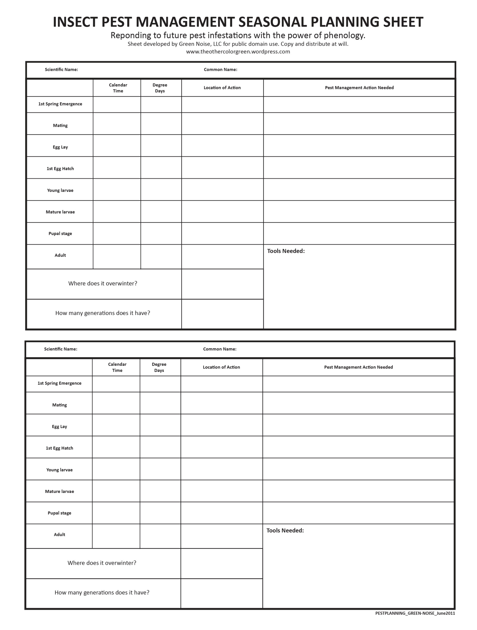

Text by Green Noise. Version 2.1. 6-1-11

